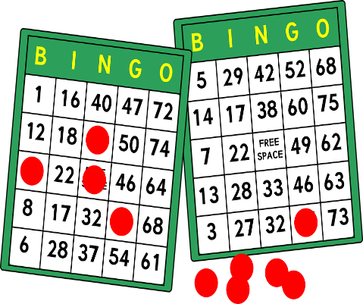 

Second Annual Older Americans Month Celebration

Date – May 9, 2025

Time- 10:00a.m. -1:00p.m.

Vendors please be set up by 9:30a.m.

Location- Washington Park Community Center- 3130 East 30th Indianapolis In 46218

**Cost to attend the event- No fee however, if you would please provide a snack and door prize for the event. If able a small donation for a Bingo prize would also be appreciated😊**

Company Name____________________________________________________________________

Contact Name_____________________________________________________________________

Contact Email______________________________________________________________________

Contact Phone_____________________________________________________________________

**We have limited space for vendors for this event. Please submit your vendor form by April 17, 2025.**

**Presented by the Division of Aging and Indy Parks**